**PORTAL APPLICATION TO SUPPORT WEB-BASED VILLAGE SERVICE AND INFORMATION CENTER ACTIVITIES**

Dhirgama Fa’iq Al Zahran  
Computer Science DepartementBINUS Online Learning   
Bina Nusantara University  
Jakarta, Indonesia, 11480 [dhirgama.zahran@binus.ac.id](mailto:dhirgama.zahran@binus.ac.id)

Fikri FirdausComputer Science DepartementBINUS Online Learning   
Bina Nusantara University  
Jakarta, Indonesia, 11480 [fikri.firdaus@binus.ac.id](mailto:fikri.firdaus@binus.ac.id)

Arief Agus SukmandhaniComputer Science DepartementBINUS Online Learning   
Bina Nusantara University  
Jakarta, Indonesia, 11480 [arief.sukmandhani@binus.ac.id](mailto:arief.sukmandhani@binus.ac.id)

**ABSTRACT**

*In the current digital era, it is essential for village governments to leverage information and communication technology to enhance the efficiency and effectiveness of public services. Information technology and the internet have revolutionized various aspects of life, including the way people interact with local governments and access public services. Therefore, the need for easy access to information, communication facilities, and efficient and appropriate services has become increasingly urgent, especially at the village level. One potential solution to address this need is the development of a web-based village portal. Recently, a research was conducted to develop a web-based village portal that could help address the problems in Pakuan Village by digitizing the information dissemination and administration process. The data collection method used in this research involved observation, interviews, and analysis of the needs of each user who would later use the village portal. The application development was carried out using the waterfall method, which is used to minimize errors in the application creation process so that the village portal application created can accommodate the needs of each user. The evaluation used to test the success of the application involved UAT test and blackbox test. UAT Test was used to test that existing features were in accordance with user needs, while blackbox testing was used to determine if existing features were working as expected.* *The research findings show that 82.5% of Pakuan Village residents find it easier to access up-to-date information and submit official correspondence. The research findings suggest that the process of digitizing information and correspondence can optimize the process of disseminating information and the process of correspondence. The development of a web-based village portal can help village governments provide efficient and effective public services to their citizens, and it is an essential step towards a more digitally-enabled future.*

Keywords: Administrative Optimization, Digitization, Information Dissemination, Village Portal

**INTRODUCTION**

Rural development today is closely related to the development of information technology, ranging from the simplest use of mobile phones to smartphones and the utilization of the internet with various features aimed at helping people in their daily activities, not only in urban areas but also in rural areas. Information and communication technology provides many benefits to human life, one of which is to simplify things such as social media correspondence and promotion of agricultural products that can be done with the help of information technology, so that the information conveyed can be easily accessed by both rural and urban communities (Asmara, 2019).

The lack of understanding among the community and village officials regarding information technology has resulted in suboptimal service to the public. Government officials who serve the community must be able to master information technology so that their service to the public can be optimal. The design of information systems and technology is needed to prepare organizations in planning the use of technology and information systems for their organization. This design is needed to align the organization's movements with the information system so that it is in harmony with the development of the organization to meet the needs of the organization's information system in the future (Badri, 2016).In today's digital era, it is crucial for village governments to utilize information and communication technology to improve the efficiency and effectiveness of public services (Afdilah, 2012). The internet and information technology have brought significant changes to various aspects of life, including how communities interact with local governments and access public services. The demand for easy access to information, communication facilities, as well as effective and timely services is becoming increasingly urgent, especially at the village level.

Pakuan Village is situated in the Bogor City region of West Java Province. According to its official profile, the village covers an area of approximately 147.5 hectares, which is quite large for a village located around 5 km away from the sub-district (Pakuan Village Profile, 2023).Currently, in Pakuan Village, conventional methods are still used to disseminate information such as village events, population data, administration, and the development of village conditions. For instance, representatives from neighborhood units (RT) and community units (RW) gather at the village hall to inform the residents.In addition to the conventional information dissemination methods in Pakuan Village, the existing administrative processes still require residents to visit the village hall in person and wait for several weeks to obtain certainty and results from the administrative process. This slow administrative process can lead to disappointment and complaints, especially when urgent administrative documents are needed.Previously, the Pakuan Sub-district had an Instant Service Access (ASINAN) application, which was used as a support tool. However, this application was mobile-based and faced challenges such as the upload of numerous files. This hindered the optimal submission of administrative requests, as many documents had to be uploaded as requirements for obtaining signatures and wet stamps from the sub-district.

State of the art on this study guides previous research related to E-Government in Sayang Village, Jatinangor District, Sumedang Regency, West Java Province (Wiratmoko & Lambelanova, 2021), The Village Security Information System (Siskamling) to support the development of digital villages (Hendrawan et al., 2022), Designing Management Information System for Al-Ikhlas Mosque Activities in City Pari Village Using Waterfall Method (Wijaya & Utomo, 2022), Design of the Population Information System in the Village of Pajajaran (Nugraha & Abdussallam, 2022), Design and Build a Web-Based Village Information System for the Acceleration of Village Services in Gampong Jantho Makmur(Gong et al., 2020).Looking at previous research,The one potentially impactful suggestion is the development of a web-based village portal. as (2018) revealed, such a portal has the potential to be a transparent and easily accessible platform for the community to access information related to public services and village activities. Furthermore, this portal can serve as an interactive platform allowing residents to provide feedback, suggestions, or complaints to the village government.

The purpose of this research is to create a web-based portal for Pakuan Village that will help address the challenges faced by the residents. By digitizing the information dissemination and administrative processes, the portal aims to provide the latest information, facilitate complaints about village issues, and handle administrative correspondence. This will optimize information dissemination and expedite administrative processes, making it easier for the residents to access services and information in the village.The problem formulation discussed in this thesis is how to digitize the dissemination of information in Pakuan Village and optimize the administrative processes. The scope of this research is limited to the development of a web-based village portal application solely for Pakuan Village, Bogor City. The research does not consider previously existing applications. The base data is collected from questionnaires given to several respondents, and the administrative process web application is limited to the submission of KTP (ID card) and KK (family card) endorsement letters.

This research aims to digitise information dissemination and develop a web-based village portal application to optimise administrative processes and public services in Pakuan Village. The benefits of this research are manifold. For the author, it is expected to enhance understanding and knowledge about the use of web-based portal applications in village governance, particularly about the development and utilisation of portal applications to improve the quality of public services and community participation in the village. For the village government, this research is expected to provide information and recommendations that can be used as a reference in the development and improvement of web-based portal applications to enhance the effectiveness of public services and community participation in the village. For the village community, this research is expected to provide an understanding of the benefits and potential of web-based portal applications in providing easier access to information and services, as well as increasing their participation in village development.

To ensure reasonable conclusions, it is necessary to take steps in conducting research, from the initial stage of analysis to the final stage containing the conclusion. The researcher uses the waterfall software development method to develop the application itself. During software development, the waterfall method is suitable for projects with well-defined requirements that are unlikely to change significantly.(Rosa, 2018).

**LITERATURE REVIEW**

Before developing the application for the village portal, researchers conducted a literature review to find previous studies that used similar methods to address the issue of digitizing information in rural areas. During their research, they found five relevant studies that supported their topic. Most of these studies compared the situation before and after the implementation of the village portal.

Researchers have obtained literature on the implementation of E-Government in Sayang Village, Jatinangor District, Sumedang Regency, West Java Province (Wiratmoko & Lambelanova, 2021). The research highlights the challenges faced by the village administration in implementing e-government, which include non-compliance with policy standards and targets, limited resources, communication barriers between organizations, and a lack of readiness among implementers towards technological advancements. The research used a qualitative and descriptive approach, collecting data through observation, interviews, and documentation. The purpose of the research was to assess the implementation of e-government in Sayang Village and identify supporting and inhibiting factors. SWOT analysis was used to formulate strategic steps, including increasing the budget for the information network, accelerating access to village administration and information systems, and updating the village administration and information systems. The results of the research suggest an urgent need to increase the budget, ensure the speed of system access, carry out routine updates, and improve the training and qualifications of human resources involved in the implementation of e-government in Sayang Village.

The second literature researchers found a journal discussing the use of The Village Security Information System (Siskamling) to support the development of digital villages (Hendrawan et al., 2022). This journal discusses the challenges of conventional information dissemination in institutions and society, which can lead to the loss of crucial information. The focus is on designing a web-based Siskamling Information System to support the development of digital villages, with the aim of improving information accessibility and facilitating communication between the community and authorities. The research adopts the Waterfall software development model, involving stages of analysis, design, implementation, integration, and maintenance. Data is collected through observation and interviews with village communities. The design phase uses Unified Modeling Language (UML) to depict a responsive system that enables access to environmental security information. The system administrator plays a crucial role in ensuring information availability. The journal concludes that the web-based Siskamling system can improve information dissemination and communication in villages, with the caveat that maintenance is necessary to address potential system weaknesses that may arise after use.

The next piece of literature that the researchers found discusses the topic of Designing a Management Information System for Al-Ikhlas Mosque Activities in City Pari Village Using Waterfall Method (Wijaya & Utomo, 2022). This research discusses about Masjid Al-Ikhlas in the village of Kota Pari is facing challenges in managing its activities, as it still relies on manual methods such as notebooks and notice boards, which result in errors and delays in communicating information to the congregation. This has led to ineffective management of funds and mosque activities due to a lack of coordination between the management and the congregation. Therefore, this research aims to develop a web-based management information system using the Waterfall method, which includes analysis, design, implementation, testing, and maintenance stages. The result is a system that facilitates activity management, provides accurate and timely information, improves coordination, and increases efficiency in mosque management. Recommendations include in-depth analysis of system requirements, responsive website design, member registration, and financial management features, as well as ongoing testing and validation.

The next piece of literature that the researchers found discusses the topic of the Design of the Population Information System in the Village of Pajajaran (Nugraha & Abdussallam, 2022), This research discusses about In the village of Pajajaran, the population information system still uses a manual method with forms from the village government, which has been proven to be ineffective and inefficient. One of the negative impacts is the frequent occurrence of errors in calculating the population when reporting to the Cicendo Sub-District, Bandung City. To address this problem, this research focuses on designing a web-based population information system for Pajajaran Village. The development method used is Waterfall, which includes requirements analysis, system design, implementation, testing, and maintenance. This system is built using PHP Native and MySQL to ensure the collection of valid population data. Suggestions involve selecting the appropriate database management system and programming language, ensuring ease of population reporting, online accessibility, and regular maintenance. This research is a positive step in using information technology solutions to improve the efficiency and accuracy of population management in Pajajaran Village.

The last literature that researchers found discusses the topic of Design and Build a Web-Based Village Information System for the Acceleration of Village Services in Gampong Jantho Makmur (Gong et al., 2020). This research discusses about the community of Gampong Jantho Makmur still relies on conventional systems for public services, which is why there is a need for a web-based village information system. The goal is to replace the conventional system, speed up services, and make it easier for the community to access information and services. The development method involves user needs analysis, graphic design using Use Case Diagrams, Activity Diagrams, and Entity Relation Diagrams, as well as front-end and back-end development using Bootstrap and Laravel. The web-based Gampong Information System (SIGAM) application, which uses PHP and Laravel, enables online certificate services and complaints. The jQuery DataTables technology is used for processing large amounts of data, and the WhatsApp API Gateway is used for sending notifications. It is suggested that SIGAM become a useful tool for the government of Gampong Jantho Makmur in managing population data, sharing information, letter services, and complaints. It is hoped that this application will be updated and its functionality and security improved in the future.

This application differs from previous research in that it facilitates the process of disseminating information by digitizing it through a web-based platform. In addition to digitization, it also includes features that optimize administrative processes, such as the submission of ID cards (KTP) and family cards (KK). Previous researchers have used similar open-source applications to develop web-based portal applications, which are common in developing countries.

The equation with previous research conducted through literature review by researchers is that in this study, the developed application is used to solve the problem of information dissemination in villages that is still conventional or manual, thus requiring a considerable amount of time for information to be received by village residents. By building a village portal application, the problem of the relatively slow information dissemination process can be solved, making it faster and more accurate so that the community is always updated with the information available in the village government system.

**RESEARCH METHODOLOGY**

When embarking on a research project for a website portal application, it is crucial to adhere to a set of well-defined guidelines. These guidelines can help researchers navigate the research process with ease and ensure that research is comprehensive and successful. Figure 1 presents a clear and concise flow of research activities that can serve as a valuable reference throughout research journey. By following these guidelines, researchers can be confident that research is thorough, accurate, and effective.

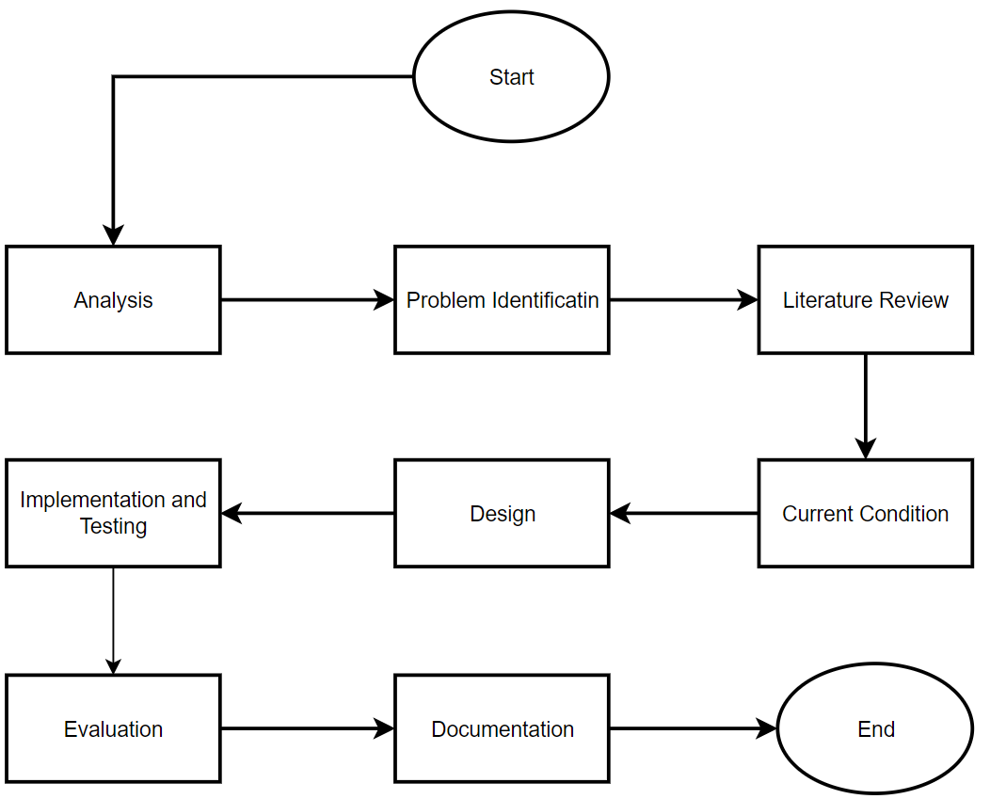

Figure 1 Framework of Thinking

1. Current Condition

The first step in this research is to analyze and identify the problem. This is followed by conducting a literature review. The next step is to analyze the current condition of the information dissemination process in Desa Pakuan and then analyze the correspondence processes at the Balai Desa Pakuan. After analyzing the main topics of this research, an analysis is conducted on the needs of the residents of Desa Pakuan and the employees of Balai Desa Pakuan.To gather data, researchers conducted interviews with five staff members of the government of Pakuan village. They also conducted a small research using a questionnaire form with 20 respondents from the villagers of Pakuan village. The results showed that 80% of the respondents had never used similar applications for administrative purposes, while 20% of the respondents answered that they had never used a similar application.

After conducting observations, interviews, and questionnaires, the researcher identified several problems occurring in Pakuan village. One of the crucial needs is a platform that can accommodate flexible access to information from various locations, reducing dependence on physical information centers. Additionally, there is a need for a system that can optimize the administration process of letter requests from users, making it faster and simpler. A system that functions as a center for information and user complaints is also important to provide easier and integrated access for users. Lastly, a system that can accurately store information history is required, allowing users to conduct further evaluation and analysis of recorded data. By considering these four aspects, the information system design can be more comprehensive and responsive to user needs.

The next step is to analyze the process of submitting a cover letter for the Population Identification Card (KTP) and Family Card (KK). The process of making it before making the village portal application can be seen in Figure 2. Initially, the application process is carried out by visiting the central government website and uploading several documents. After uploading the documents, the applicant verifies them. If the records are approved, the result of submitting a cover letter will be displayed on the applicant's side in the existing application.

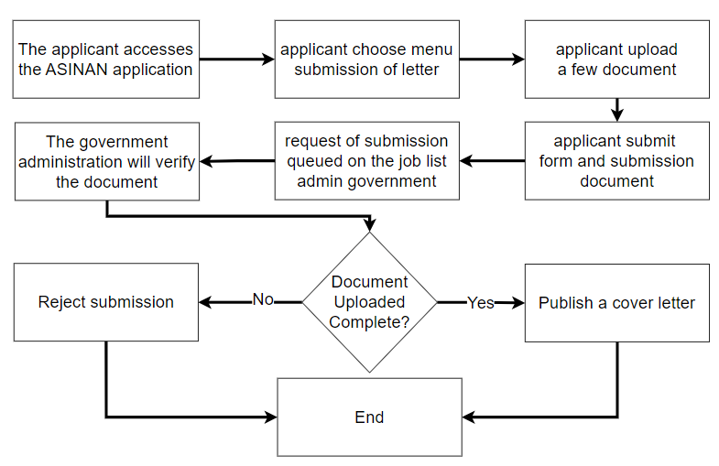

Figure 2 The Procedure for Submitting a Letter of Request

After analyzing the process of creating a cover letter, the next step is to examine how information is disseminated in Pakuan village. The process of disseminating information can be seen in Figure 3. Before it is shared with the community, the village head informs the head of the RW. Then, the head of the RW conveys the information to the RT head, who then informs the residents. The current process of disseminating information has been ongoing for quite some time, which makes it take a considerable amount of time to reach the residents. This is because the process has to go through several stages to ensure that the information is conveyed effectively and accurately to the residents. On the one hand, this process is still quite manual, and it can become even longer if there are obstacles at any stage. Moreover, there may be delays in delivering information from the village head to the residents if one of the responsible individuals faces challenges or is unavailable during a particular stage.

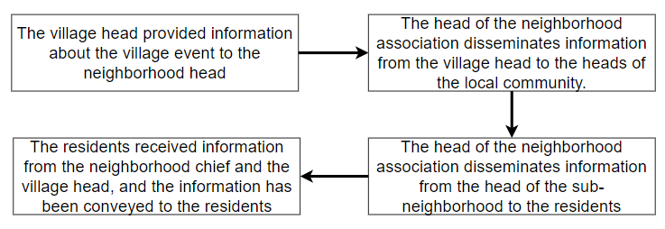

Figure 3 Process of Information Distribution

After analyzing the current condition of submitting a cover letter and how information is disseminated in Pakuan Village The team of researchers carefully analyzed the requirements of the Pakuan Village residents through a comprehensive survey, regarding the existing information dissemination and administrative processes. Some residents in Pakuan Village are already familiar with the Instant Service Access Application (ASINAN), but it cannot be fully utilized due to a lack of education and its availability only on a mobile platform. Moreover, not all residents have mobile devices that meet the standard specifications for installing the ASINAN application on their mobile devices. Therefore, the resulting system is expected to address the issues related to information dissemination in Pakuan Village transparently. It should be accessible to every resident of Pakuan Village anytime and anywhere, provided that they have internet-connected devices. Additionally, the aim is to optimize the administrative processes, which often involve numerous documents and lengthy processing times, by developing a web-based software application. This application is intended to reduce administrative processing time and provide transparent and up-to-date information.

After conducting the above analysis, a proposal can be made for a web-based village portal application. This would facilitate the Pakuan Village community in obtaining the latest information, making complaints about the village environment, and handling administrative correspondence.The method employed in the development of the village portal application utilizes the waterfall method. It begins with the analysis of application requirements, followed by the design of system architecture and user interface, implementation of coding, verification through functional testing in the development environment, deployment to the production environment, and ongoing maintenance.

1. System Design

After conducting an observation of the current conditions in Pakuan village, the next step is to design a system. The system will be based on the results of the observations, which can be seen in Figure 4. The tasks of each role have been visually explained in the picture as they align with the use case diagram. Use case diagrams are helpful for developers and stakeholders to understand the system’s functionality, identify needs, and design and test systems more efficiently (Fintri *et al.,*2019).

The village portal application has two types of users: admin and user. The admin can perform various actions such as viewing the list of users, viewing the event page, creating, editing, and deleting an event page, viewing the report page, viewing the file documentation page, and editing the status of the file documentation page. On the other hand, the user can view the file documentation page, create, edit, and delete a file documentation page, view the report page, create, update, and delete a report page.The decision to exclude the superadmin from this system design is based on the fact that the superadmin is responsible for developing the application. Therefore, the system design does not include any superadmin functionalities. In case of any errors, the developer can refer to the application logs and use the admin account to check requests from users who are submitting correspondence or reporting incidents in their environment.

.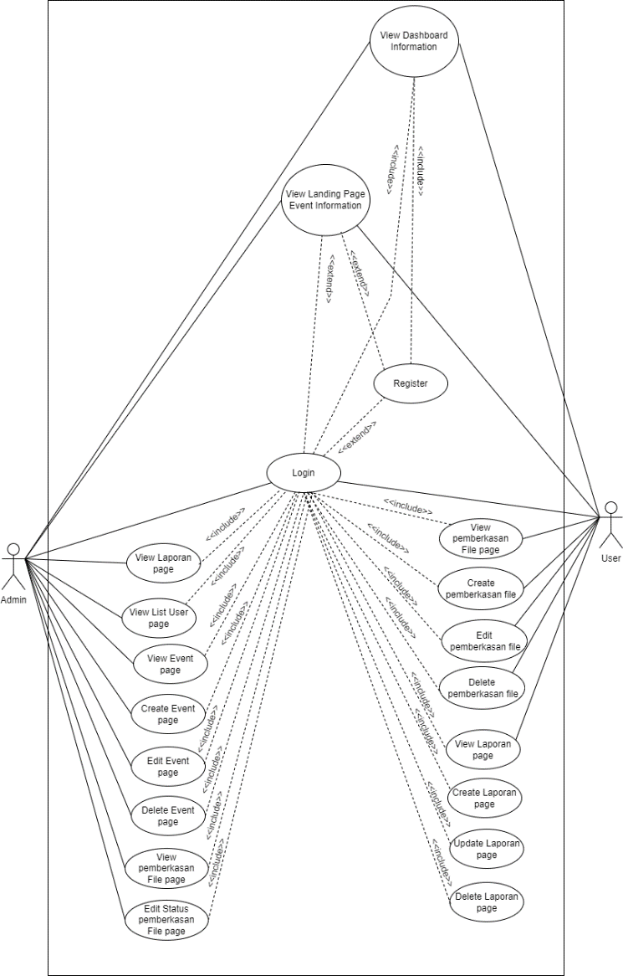

Figure 4 Use Case Diagram

Once the visual design of the user’s requirements is complete, the next step is to design the necessary modules in the system. Figure 5 shows the system modules that will be utilized. The Class Diagram is a useful tool as it provides a clear understanding of the system structure, making analysis and design easier. It also assists in the overall development and documentation of the system (Mardiani, 2017); the class diagram has been divided into six major modules. One of them is the “report” module, which is used to store, update, and view the results of reports created by users or residents. Another module is the “user” module, which stores users created by residents and displays them in the admin module. The “submission” module is used to store, update, and view requests for endorsement letters made by residents. For the admin role, this module is used to view and update the status of endorsement letter requests previously submitted by residents. The “event” module is used to create, edit, and display village events created by the admin role. The “modification” module is used for sending emails to the email addresses of users registered previously. This module is used when a user has submitted a letter, and the status of the letter submission will be sent to the user’s or resident’s email. Lastly, the “reset password” module is used to change the password if a user forgets it.

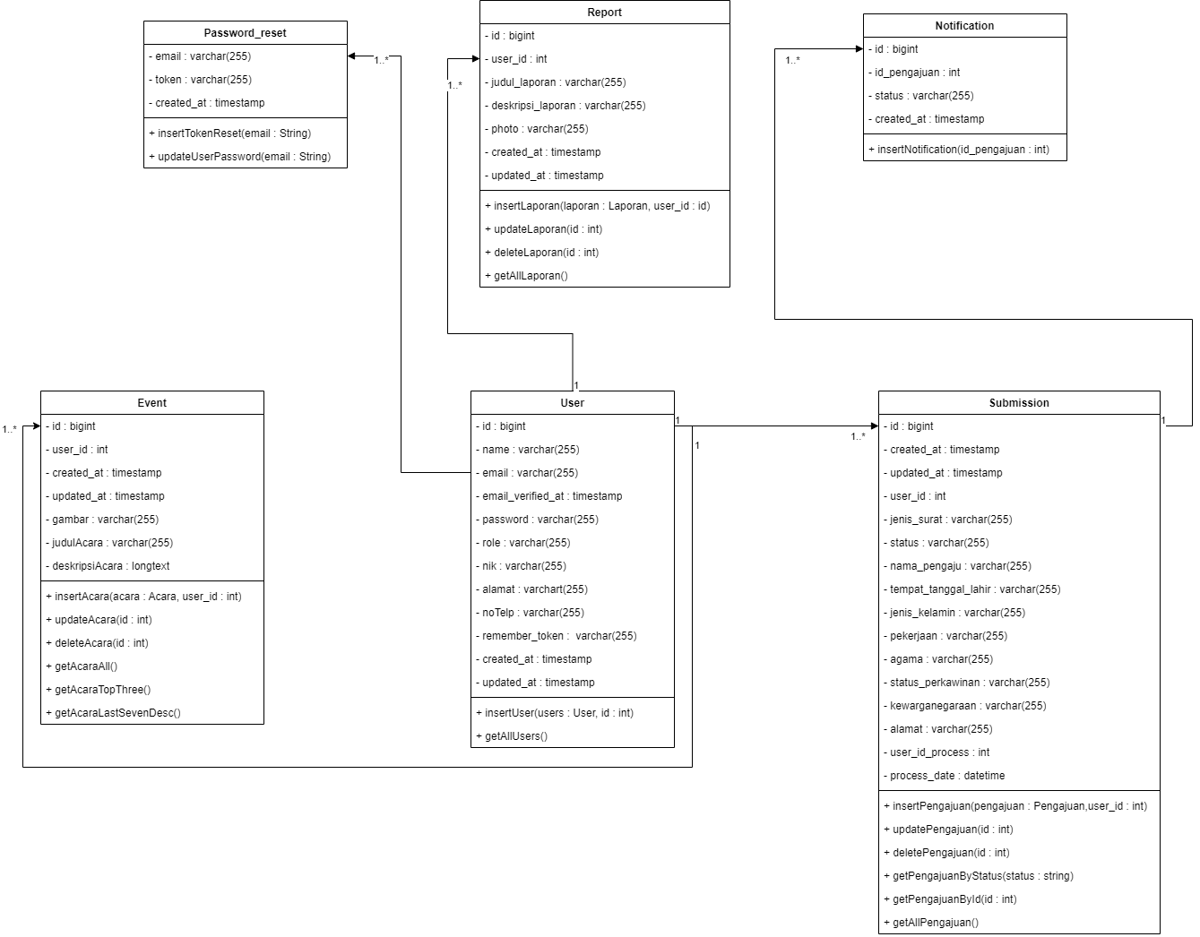

Figure 5 Class Diagram

The testing method in this research utilizes User Acceptance Testing (UAT) with dimensions based on ISO 9126, and the Likert scale is employed for measurement. User Acceptance Testing is considered the final stage in the testing process, where the system has completed the development phase (Chamida *et al .*2021). UAT aims to ensure that the solution created aligns with the users’ system requirements (Luh *et al.*, 2022). Acceptance Testing is a crucial part of the software testing sequence ss conducted before the software is developed and launched to system users (Chamida *et al,*2021).

**RESULTS AND DISCUSSION**

1. Implementation

Once the implementation environment has been defined, the application's core feature can be viewed in Figure 6. The figure displays the interface of the main banner village event, which showcases the upcoming event for every villager from Pakuan Village. The banner shows the three latest histories of the event that have already passed or an upcoming event that will be held. Villagers do not need to register first to see the banner event, as it appears after they type the URL of the web-based portal application.

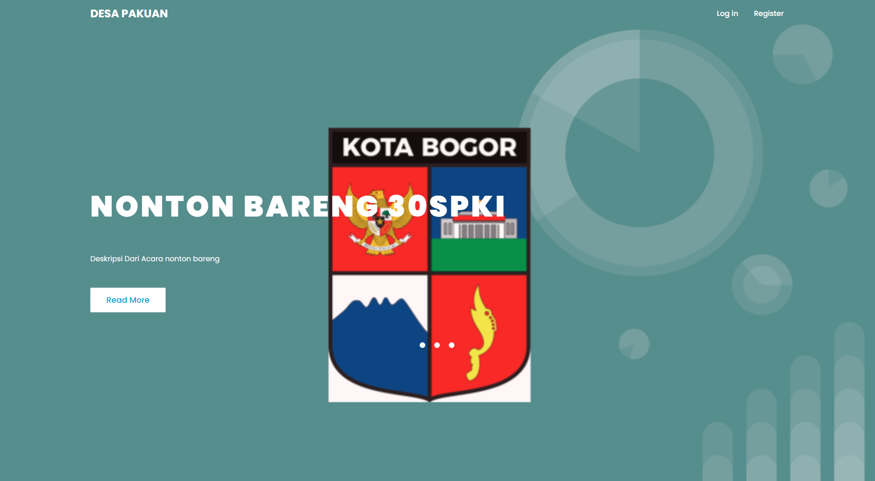

Figure 6 Banner Event Village

This implementation is for the second feature, which involves submitting two types of cover letters - one for an identity card and the other for a family card. Villagers can request the submission of these letters through the menu provided. Once the letter is asked for, the admin staff of the government will review it and process it only if all the data provided by the villagers is accurate and complete. If the information provided is incorrect or incomplete, then the letter will be rejected, and the villager will have to request it again, as can be seen in Figure 7.

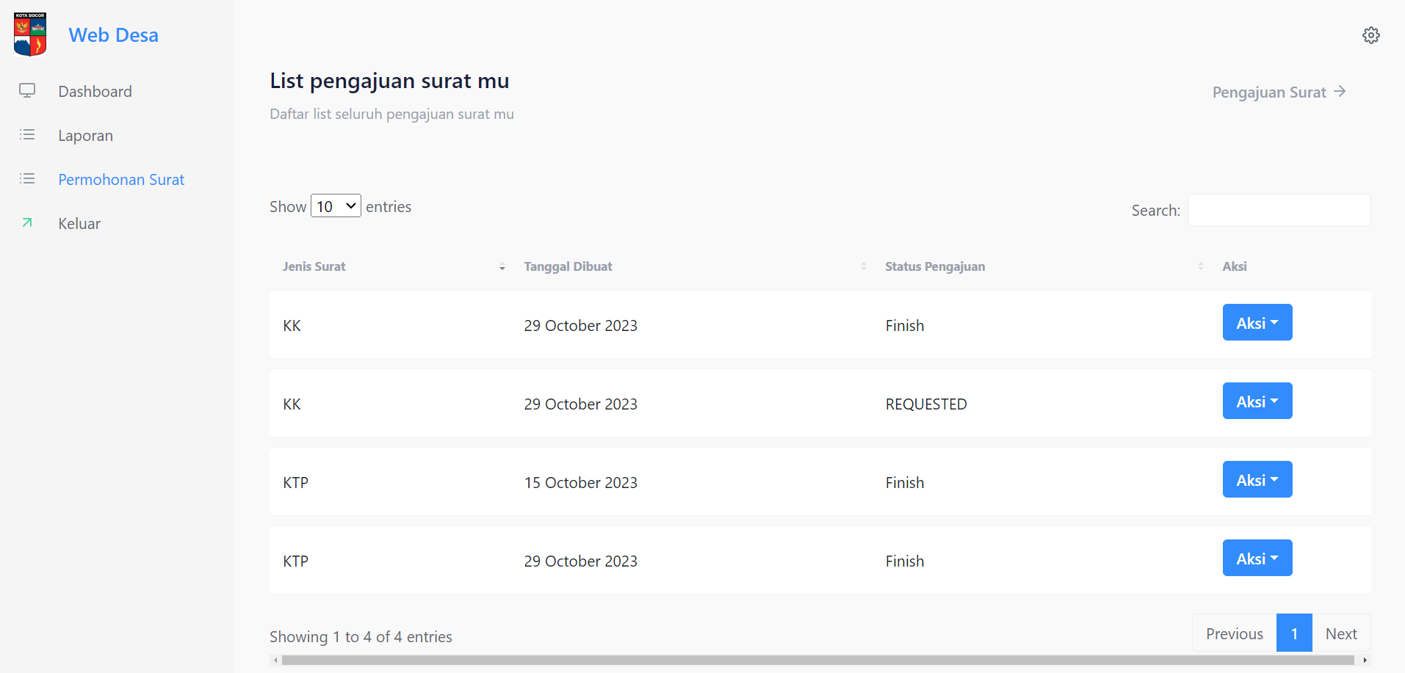

Figure 7 Submission of Letter Menu

The following report presents the results of tests on the newly developed system. The tests included black box testing and user acceptance testing (UAT). In the first evaluation, researchers used black box testing to assess the performance of the leading feature portal web-based application. The aim was to ensure that the feature already created was functioning correctly and to identify any bugs or glitches that may occur in the application. After testing the main core feature, the results of the black box testing are presented in Table 1. Table 1 shows the test results for the "Banner Event Village" menu, which shows that the menu successfully creates, reads, updates, and deletes previously created event villages.

Table 1 Blackbox Testing Banner Event Village Admin Role

|  |  |  |  |  |
| --- | --- | --- | --- | --- |
| **Input Data** | **Expected Data** | **Observation** | **Criteria for Evaluating Results** | |
| **Successful** | **Failed** |
| View information on the last three village events on the landing page. | Successfully display the last 3 data of village events that have been created. | The last three village events data were successfully displayed. | ✓ | - |
| Display the history of previously made village events. | Successfully display the history of previously made village events. | The history of previously created village events was successfully displayed. | ✓ | - |
| Create a village event. | Fill in the title of the event, description, and event photo. | Data was successfully saved to the database. | ✓ | - |
| Modify village event data. | Successfully modify village events as desired. | Village event data was successfully updated in the database. | ✓ | - |
| Delete a village event. | Successfully delete the selected village event data. | Village event data was successfully deleted from the database. | ✓ | - |
| View detailed data of previously made village events | Successfully display detailed data on village events. | Detailed data of village events successfully viewed and displayed. | ✓ | - |

The next step in the process after obtaining the results of testing the menu banner event village is to check the results of testing the view information of the last three village events on the landing page. According to Table 2, the landing page has been successfully designed to display the previous three village events that an admin role has created. This means that anyone can view this landing page without the need to register first. Once residents know the website of Portal Desa, they can easily access it, and the first thing they will see is the last three village events that have taken place. This feature is handy for informing residents about the latest happenings in their village and encouraging them to participate in community events.

Table 2 Blackbox Testing Landing Page

|  |  |  |  |  |
| --- | --- | --- | --- | --- |
| **Input Data** | **Expected Data** | **Observation** | **Criteria for Evaluating Results** | |
| **Successful** | **Failed** |
| View information on the last three village events on the landing page. | Successfully display the last 3 data of village events that have been created. | The last three village events data were successfully displayed. | ✓ | - |

Once have reviewed the testing landing page, the next step is to check the result of the testing submission in the Letter Menu from the user role. The Letter Menu is a feature that allows users to create, update, view, and delete letter submission requests. This menu is accessible to users who have been granted the necessary permissions. To check the submission result, users can edit the submission status via email or by checking the website directly. This means that users can update the status of their submission by sending an email to the relevant authority or by logging into the website and updating the status themselves. It is important to note that the results of the blackbox testing can be found in Table 3. This table provides a detailed breakdown of the testing results, including any issues that were identified during the testing process. Users should review this table carefully to ensure that they are aware of any issues that may impact their submission.

Table 3 Blackbox Testing Submission of Letter User Role

|  |  |  |  |  |
| --- | --- | --- | --- | --- |
| **Input Data** | **Expected Data** | **Observation** | **Criteria for Evaluating Results** | |
| **Successful** | **Failed** |
| Display the history of previously created letters. | Successfully display the history of previously made letters. | History of previously created letters successfully displayed. | ✓ | - |
| Create a letter. | Choose the type of letter request (ID card or family card), and fill in data such as name, place and date of birth, gender, occupation, religion, nationality, marital status, and address. | Data for creating letters is successfully saved to the database. | ✓ | - |
| Modify letter data. | Modify letter data such as name, place and date of birth, gender, occupation, religion, nationality, marital status, and address. | Data for modifying letters was successfully updated in the database. | ✓ | - |
| Delete a letter. | Successfully delete the selected letter data. | Letter data was successfully deleted from the database. | ✓ | - |
| View detailed data of previously made letters. | Successfully display detailed data of the letter. | Detailed data from the letter was successfully viewed and displayed. | ✓ | - |

During blackbox testing, the final step involves verifying the result of the menu submission of a letter from the admin role. The admin role has recently been updated with four new features to enhance its functionality. These features include the ability to view the history of the completed process submission of letters, view the detailed submission of letters, and the core feature to update the status of submission of letters. Whenever an admin changes the status of a submission, the status will be automatically updated to the user role by sending an email with the current status of the submission of the letter. This ensures that all parties involved are kept up-to-date with the status of the submission. To evaluate the effectiveness of the blackbox testing, the result of the submission of the letter can be viewed in Table 4. This table provides a detailed breakdown of the testing results, allowing for a comprehensive analysis of the testing process.

Table 4 Blackbox Testing Submission of Letter Admin Role

|  |  |  |  |  |
| --- | --- | --- | --- | --- |
| **Input Data** | **Expected Data** | **Observation** | **Criteria for Evaluating Results** | |
| **Successful** | **Failed** |
| Display the history of previously created letters. | Successfully display the history of previously made letters. | History of previously created letters successfully displayed. | ✓ | - |
| View detailed data of previously made letters. | Successfully display detailed data of the letter. | Detailed data from the letter was successfully viewed and displayed. | ✓ | - |
| Change the status of submitted letters. | The status of the submitted letter can be changed as desired. | Status can be changed and saved as desired. | ✓ | - |
| Display letters that have been marked as completed. | Successfully display data of letters that have been marked as completed. | Data on completed letters successfully displayed. | ✓ | - |
| View detailed data of completed letters. | Successfully view detailed data of completed letters. | Detailed data of completed letters successfully displayed. | ✓ | - |

After conducting thorough black box testing, the researchers have confirmed that all the tested features of the application are running smoothly and are now ready to be tested by other villagers and government staff in Pakuan village. The black box testing involved testing the application's functionality without any knowledge of its internal workings. The results were positive, and no bugs were found after multiple tests on the application. Additionally, the researchers have implemented a feature that prevents users from forgetting to fill in mandatory fields, ensuring that users always provide the necessary information. Apart from black box testing, the researchers also conducted User Acceptance Testing (UAT) (Suprapto,2021). with residents of Village Pakuan and some government employees in Kelurahan Desa Pakuan. The UAT involved presenting a questionnaire consisting of 10 questions to 25 respondents, including 15 village residents and ten government employees in Kelurahan Desa Pakuan. The questionnaire categories include Strongly Agree (SA), Agree (A), Cautiously Agree (CSA), and Disagree (D). The questionnaire aimed to gather feedback on the application's usability, functionality, and overall user experience. The researchers carefully analyzed the responses and used the feedback to make necessary improvements to the application.

As part of the testing process for the village portal application, a questionnaire has been provided to a group of 25 selected respondents. The researchers will conduct interviews and observe the respondents to evaluate the effectiveness of the application in meeting the user requirements. The questionnaire aims to gather feedback from both the village residents and the government employees working in the Pakuan village administration. The questionnaire consists of a set of questions that are designed to evaluate the user experience of the village portal application. The questions are based on the Likert scale, which is a commonly used rating scale that measures the level of agreement or disagreement with a statement. The respondents will be asked to rate their level of agreement or disagreement with each statement on a scale of 1 to 4, with 1 being strongly disagree and 4 being strongly agree.The purpose of the questionnaire is to identify any areas where the application may need improvement, as well as highlight its strengths and successes. The feedback gathered from the respondents will be used to refine and enhance the village portal application, ensuring that it meets the needs of all users.

To calculate the observation score, the scores for each question will be added and multiplied by the score weight based on the Likert scale (Suasapha,2020). The maximum score is the highest on the Likert scale multiplied by the number of questions, which is 4 x 10 = 40. The expected score is the total score multiplied by the number of respondents, which is 25 x 40 = 1000. After calculating the scores from 25 respondents, the final score is 825 out of 1000, resulting in a successful application chance of 82.5%. Overall, the questionnaire is an important tool in evaluating the effectiveness of the village portal application. The feedback gathered from the respondents will help to ensure that the application meets the needs of all users and is a valuable resource for both the village residents and the government employees working in the Pakuan village administration.

After conducting thorough User Acceptance Testing (UAT) and black-box testing, the researchers closely monitored the usage of the village portal for a few weeks following testing and hosting. They observed a significant increase in the usage of RAM and CPU on the server, which coincided with a growing number of users accessing the web portal. The researchers also monitored the application's performance when multiple users accessed the website simultaneously. The results indicated a slight decline in the performance of the village portal website, although the decrease was not too significant. To address this issue, the researchers decided to enhance the server's specifications to ensure smoother operation of the website, preventing user complaints about slow performance. They upgraded the server's RAM and CPU to handle the increased traffic and usage. Additionally, the researchers tuned the database to optimize the data retrieval process. This optimization aimed to maintain optimal database performance, even with a large volume of data being retrieved.The researchers also implemented a caching mechanism to reduce the number of database queries and improve the website's response time. They also optimized the website's code to reduce the number of HTTP requests and minimize the website's load time. These measures helped to improve the website's performance and ensure a seamless user experience. Overall, the researchers took a proactive approach to address the performance issues of the village portal website. Their efforts resulted in a significant improvement in the website's performance, ensuring that users can access the website quickly and efficiently without any issues.

**CONCLUSION**

The results of the black box testing conducted on the web-based village portal application system for the community and government employees of Kelurahan Desa Pakuan showed that the system is usable, with a 100% success rate from 25 respondents. This indicates that the testing was successful and the system is functioning as intended. Furthermore, the User Acceptance Test (UAT) was conducted with 25 respondents using the Likert scale calculation, and it yielded a score of 82.5%, which is considered good and can be used. The UAT was designed to evaluate the system's usability, functionality, and overall user experience. Based on the UAT results, it can be concluded that the web-based village portal application system has been designed based on previous observations and feedback from users.However, upon gathering feedback from users, it was noted that there were concerns regarding the design and font of the web portal. Specifically, users found the design to be too plain and lacking in visual appeal. Additionally, the font used on the website was deemed too small, making it difficult to read and navigate. As a result, users expressed a desire for improvements to be made in these areas to enhance the overall user experience. In conclusion, the web-based village portal application system for the community and government employees of Kelurahan Desa Pakuan has been tested and evaluated, and it has been found to be usable and functional. However, there is room for improvement in terms of the design and font of the web portal to enhance the overall user experience.

In order to enhance the upcoming application that will utilize the concept of an application portal, it is highly recommended to focus on the design aspect that represents the latest design trends. This will ensure that the application is visually appealing and user-friendly. Additionally, researchers suggest incorporating more complex features that will bring a more digital feel to the village environment. These features could include interactive maps, real-time updates, and community forums where villagers can share their ideas and opinions. by implementing these features, every person in the village will have access to updated information and can participate in the government system to design their village to be more advanced and faster. This will not only improve the quality of life for the villagers but also promote a sense of community and collaboration. Furthermore, it will enable the government to make informed decisions based on the feedback and suggestions of the villagers, leading to more effective policies and initiatives.

**REFERENCE**

Afdilah. (2012). Sistem Informasi Sumber Daya Manusia Berbasis Web Studi Kasus: PT. XYZ. Jurnal Teknik Informatika, 5(1), 9-15.

Asmara, J. (2019). Rancang Bangun Sistem Informasi Desa Berbasis Website: Studi Kasus Desa Netpala. Kupang: STIKOM Uyelindo. Nusa Tenggara Timur 85111.

Badri, M. (2016). Pembangunan Pedesaan Berbasis Teknologi Informasi Dan Komunikasi (Studi pada Gerakan Desa Membangun). Jurnal RISALAH, 27(2), Desember.

Chamida, M. A., Susanto, A., & Latubessy, A. (2021). Analisa User Acceptance Testing Terhadap Sistem Informasi Pengelolaan Bedah Rumah Di Dinas Perumahan Rakyat Dan Kawasan Permukiman Kabupaten Jepara. Indonesian Journal of Technology and Informatics Sciences, 3(1), 36–41. doi: 10.24176/ijtis.v3i1.7531.

Dewi, S. K., & Garside, A. K. (2014). Perancangan Website Sebagai Media Promosi dan Penjualan Pada Home Industry Abon. Jurnal Teknik Industri, 15(2).

Fintri Indriyani, M.Kom, Yunita M.Kom, Dinda Ayu Muthia, M.Kom, Artika Surniandari, M.Kom, & Sriyadi, M.Kom. (2019). Analisa Perancangan Sistem Informasi. Jakarta.

Gong, Y., Chen, K., Gu, F., & Wang, F. (2020). The design and implementation of a campus web information system based on micro-service architecture. Journal of Physics: Conference Series, 1629(1). https://doi.org/10.1088/1742-6596/1629/1/012044

Hendrawan, J., Perwitasari, I. D., Ritonga, R. S., & Hendrawan, J. (2022). The Village Security Information System ( Siskamling ) to Support Digital Village Development, 2(1), 1–5.

Luh, N., Kartika, A., & Sarja, Y. (2022). User Acceptance Testing Virtual Tour Desa Wisata Cau Belayu Tabanan. Jurnal Teknologi Informasi dan Komputasi, 8(3), 430–438.

Mardiani, G.T., S.Kom., M.Kom. (2017). Object Oriented Analysis and Design. Bandung.

Nugraha, I., & Abdussallam, F. (2022). Design of the Population Information System in the Village of Pajajaran. Journal of Applied Engineering and Technological Science, 4(1), 190–201. https://doi.org/10.37385/jaets.v4i1.1012

Rosa, A. S., & Shalahuddin, M. (2018). Rekayasa Perangkat Lunak Terstruktur Dan Berorientasi Objek. Bandung: Informatika.

Suasapha, A. H. (2020). Skala Likert Untuk Penelitian Pariwisata; Beberapa Catatan Untuk Menyusunnya Dengan Baik. Jurnal Kepariwisataan, 19(1), 26–37. doi: 10.52352/jpar.v19i1.407.

Suprapto, E. (2021). User Acceptance Testing (UAT) Refreshment PBX Outlet Site BNI Kanwil Padang. Jurnal Civronlit Unbari, 6(2), 54. doi: 10.33087/civronlit.v6i2.85.

Wijaya, R. F., & Utomo, R. B. (2022). Designing Management Information System for Al-Ikhlas Mosque Activities in Kota Pari Village Using Waterfall Method, 2(1), 0–5.

Wiratmoko, E., & Lambelanova, R. (2021). Implementation of E-Government on Village Administration and Information System in Sayang Village Jatinangor District Sumedang Regency West Java Province. International Journal of Governmental Studies and Humanities (IJGH).